Request for Investment: Seattle Preschool Program Provider Facilities Fund

School Year 2022-2023

INTRODUCTION

The Department of Education and Early Learning (DEEL) is notifying any agency under contract to provide preschool services for the Seattle Preschool Program (SPP) or the Pathway Program of a funding opportunity through the City of Seattle 2018 Families, Education, Preschool and Promise (FEPP) Levy. The FEPP Levy aims to achieve educational equity, close opportunity gaps, and build a better economic future for Seattle students.

The City has provided quality supports to preschool providers and tuition assistance to families through levies since 2004. In 2015, the City launched SPP. Around the same time, DEEL also created a preschool program called Pathway to support providers to transition to SPP by providing additional supports needed to meet SPP quality standards. The goal of SPP is for Seattle children to access and utilize high-quality early learning services that promote success in kindergarten, with the following outcomes:
- Children are kindergarten ready
- Learning environments are evidence based, high-quality, culturally responsive, and equitable
- Children and families have multiple ways to access high-quality early learning services
- Race-based opportunity gaps are closed

Research demonstrates that high-quality learning environments support improved academic outcomes. In working with community to identify the challenges of participating in SPP, DEEL received feedback from partners citing the following as ongoing challenges for sustainability: (1) the lack of available and licensable space as a barrier to SPP program expansion, and (2) organizational capacity related to board development, fundraising plans, human resources, and financial management. DEEL will support in the improvement and expansion of early learning facilities and environments by investing in an annual SPP Provider Facilities Fund RFI.

INVESTMENT GOALS AND OVERVIEW

Under the FEPP Levy, the SPP Provider Facilities Fund will support capital projects that:
- Improve quality or help providers meet preschool facility licensing standards.
- Expand space in existing SPP preschool facilities.
- Start new facilities, either from the ground up or by substantially remodeling existing buildings to use as part of SPP.

Allocations under this RFI will be made in the form of a grant tied to specific commitments to provide SPP services. Recipients will manage their own capital projects, and grant funds will be distributed to recipients based on negotiated project milestones.

Minimum Qualifications and Eligibility

An agency/provider is eligible for consideration if it is:
- A center, school, or home-based provider under contract with DEEL to provide preschool services for SPP or Pathway.
- In good standing with DEEL and not on a corrective action plan.

Proposals for the Provider Facilities Fund must meet the following basic requirements:
- Funds must be used solely to improve or expand preschool-related instructional space, as mutually agreed upon by DEEL and the agency.
- If the project serves multiple uses, only activities and costs directly related to delivering preschool services are eligible for funding.
- All activities must meet the definition of “eligible activities” as defined below.
- If the grantee is a Pathway provider, they will commit to participating in SPP by the following school year. If the project is not complete by the start of the school year, the agency must work with DEEL to issue an exception. This may require the agency to continue as a Pathway provider until the project is completed.
- The proposal must demonstrate the agency has the legal authority to undertake the proposed project on the proposed property by meeting the Site Control requirements (see pages 8-9).
- Recipients of funds are required to pay prevailing wages (see Prevailing Wage Requirement, page 9).
- Recipients must dedicate improved facilities to SPP for between 3 and 15 years, depending on the size of the City’s investment (see Table 3: Service Commitments, page 7).
- Funding match will be required depending on the proposal amount (see Table 4: Funding Match, page 8).
For grants over $250,000, the provider or grantee will commit to additional protections for the City, which may include property covenants, deeds of trust, or other legal agreements (see Service Commitment Security, page 7).

Funding request policies:
- Center and school-based providers are eligible to apply for up to $500,000.
- Home-based agencies participating in SPP are eligible to apply for up to $75,000.
- The minimum funding request is $5,000.
- Funding requests cannot exceed $500,000.

Any agency or project deemed ineligible will be disqualified, and its proposal will not be reviewed or evaluated.

As a condition of receiving funding, a successful agency will be required to enter a contract with DEEL. The commitment will include use of the project improvements to provide preschool services through the Seattle Preschool Program indexed to the amount of funds received.

Eligible activities include:
- Construction, renovation, or rehabilitation of preschool facilities, which includes instructional space as well as other related space such as kitchens, bathrooms, storage, or other space associated to the instructional space (classroom or home-based).
- Design, construction, renovation, or rehabilitation of outdoor play space in accordance with state licensing regulations and best practice.
- “Soft costs” or any project costs that are not construction but directly related to the development of an eligible SPP facility (which may include design, project management, and permitting costs).
- Improvements that provide accessibility to persons with disabilities.

Ineligible activities include:
- Renovation costs not directly connected for use in an approved SPP facility.
- Renovation costs for infant- or toddler-age classrooms or any space not used by children ages 3 through 5.
- Acquisition of existing facilities or land.
- Deferred maintenance or repairs which do not directly contribute to making the project or property suitable for use as an SPP classroom.
- The purchase of equipment or furniture.

The agency will manage and oversee their capital projects and will be responsible for any cost overruns and for maintenance following completion. Funds that the City makes available under this RFI require commitments that the project or facility will be used for the SPP or SPP Pathway program.

Anticipated Funding

DEEL has approximately $825,000 available for awards in the 2022-2023 school year. DEEL anticipates reserving about 10% of the funds for eligible projects under $75,000 and following a process to support home-based providers listed in Appendix B. Additional funds may be made available in subsequent years of the levy period.

The City reserves the right to reject all proposals and the right to negotiate with an agency or provider as follows:
- Regarding the amount of funding to be provided; this may differ from the amount requested in the proposal
- Terms or conditions of awards resulting from this RFI process

EVALUATION CRITERIA

Responses will be evaluated using a two-step process. First, proposals will be reviewed for technical compliance with the requirements of this RFI. Second, submissions that are technically compliant will be evaluated by a panel of reviewers using criteria outlined in this section. Both steps are described in greater detail below.

- Initial Screening for Technical Compliance and Evaluating
The checklist below (Table 1) lists the required elements of each proposal. If any of these elements are missing or incomplete, the proposal may not be further evaluated. DEEL reserves the right to waive immaterial defects or irregularities in any submission. Follow-up phone calls may be made to obtain additional information.

Table 1: Technical Compliance
Complete | Item | Documentation
Yes No | Submitted on time | N/A
Yes No | Submitted one electronic copy of application to DEEL | Proposal
Yes No | Provided documentation of minimum site control of the proposed site and the ability to maintain site control through the applicable services. | Site control documentation such as rental agreement or deed
Yes No | If site is leased, provided written authorization from the landlord to make tenant improvements outlined in the proposal. | Landlord letter
Yes No | Evidence of the facility’s current ADA compliance or plan for how facility will become ADA compliant (only needed if licensed). | Current state licensing inspection report
Yes No | Fully complete project schedule form provided within the proposal materials. | Attachment 2: Project Schedule
Yes No | Fully complete project budget form provided within the proposal materials. | Attachment 3: Project Budget Template
Yes No | Submitted labor harmony attachment and confirmed standard practices and policies that uphold City principles that agencies work to prevent labor disputes, which may lead to work stoppages or adversely impact the ability of FEPP Levy-funded programs to achieve intended outcomes | Attachment 5: Labor Practices and Policies
Yes No | Submitted evidence of commitment of other funding sources (if request is greater than $250,000). | Funding commitment letter(s)

- Proposal Scoring
While this is a competitive grant process, there is no guarantee that any proposals will receive funding. A review committee will first score each of the proposals meeting the technical compliance requirements using a set of criteria. The committee will establish a group score for each proposal. All projects must receive at least 50 points (see scoring criteria in Table 2) in the scoring review to be further considered for funding.
If a proposal meets the minimum scoring threshold and are tied, the additional criteria below will be used to determine which proposals will be selected for further consideration. The additional criteria to be used for selection are:
- Produce a net increase in licensed capacity (for example, adding an additional licensed classroom or adding more licensed slots to an existing classroom) for the facility undergoing the capital improvement.
- Submit a project budget that was informed by design and construction experts.
- Demonstrate the solicitation of WMBE (women- and minority-owned companies) as part of the project team.

Table 2: Proposal Scoring Criteria
RFI Rating Criteria | Available
- Project Design – Feasibility  - Aligns with and supports the agency’s long-term strategic plan.  - Shows a realistic and comprehensive schedule for the project, demonstrating an ability to complete project.  - Demonstrates regulatory feasibility (building code, zoning, ADA, environmental, and licensing), or a clear plan to address regulatory barriers.  - Have identified a well-qualified project team that may include an architect, project manager, and/or general contractor.  - Budget is aligned with work plan and expenses tied directly to the proposed services.  - Shows a realistic and reasonable cost estimate and budget, including prudent contingencies. | 20
- Project Design – Impact  - Project supports community and SPP needs as described in the application.  - Applicant clearly demonstrates how the project will lead to a net increase in the licensed capacity in SPP preschool classrooms and/or other learning environment quality improvements (such as health & safety).  - Location of the project is in a geographic location deemed to be a high priority for the Seattle Preschool Program (see Appendix A for details)  - Project is in a geographic location where currently there are fewer than 5 school or center-based classrooms within the SPS elementary school attendance zone (see Appendix A).  - Project supports children furthest from educational justice. | 30
- Past Experience and Demonstrated Ability  - Has demonstrated organizational stability in the delivery of effective childcare services.  - Has experience with childcare construction, renovation, and/or expansion. | 15
- Organizational and Administrative Capacity  - Has a proven track record of managing public funds, operating programs and/or capital projects.  - Demonstrates financial stability and management capacity to plan and implement its proposed project.  - Demonstrates leveraging additional funding sources outside of this grant (if necessary). | 35
Maximum points | 100

REQUEST FOR INVESTMENT TIMELINE

EVENT | DATE/LOCATION*
Phase 1: Request for Investment*
Request for Investment (RFI) Release | May 2, 2022  RFI will be posted: http://www.seattle.gov/education/for-providers/funding-opportunities
RFI Information Webinar | May 3, 2022  Pre-recorded webinar will be posted:  http://www.seattle.gov/education/for-providers/funding-opportunities
Question and Answer Period | May 2 – June 3, 2022  No calls nor individual meetings will be accepted. Email all questions to:  DEELFunding@seattle.gov
RFI Submission Deadline | June 12, 2022 by 11:59 PM  See “Instructions to Applicants”
Phase 2: Evaluation*
Applications Reviewed and Rated | June 13-21, 2022
Scoring Session(s) | June 22-29, 2022
Notifications Issued to Applicants | July 2022
*Dates/locations subject to change

funding conditions
This section outlines conditions the agency will need to meet to receive awarded funds.

Project Expenditure and Completion
Upon receiving notice of proposal approval, the agency will be required to meet with representatives of the City to review the project schedule and enter contract negotiations. The grant agreement shall outline major milestones for the project and payment points based on milestones. The goal will be to have a final grant agreement within 90 days of the notification of approval.

All projects should be completed within one calendar year from the contract execution start date, except for:
- Projects funded above $250,000 should be completed within an 18-month period.
- Projects funded at $500,000 should be completed within a 24-month period.
Service Commitments Security
Approved agencies are required to provide commitments to use the capital improvements for SPP or Pathway. The type and nature of the commitment will vary depending on the level of award. Commitments are outlined below in Table 3.

Table 3: Service Commitments
Tier | Grant Amount | Required Commitment to City of Seattle
All | All | For SPP Pathway providers, commitment for any classrooms improved through this funding to participate in SPP within one (1) year.
1 | Awards $75,000 or less | An agency receiving funds must commit any classrooms improved through this funding to participate in SPP for no less than three (3) years, unless otherwise mutually agreed to by both parties.
2 | Awards between $75,001 and $250,000 | An agency receiving funds must commit any classrooms improved through this funding to participate in SPP for no less than five (5) years, unless otherwise mutually agreed to by both parties.
3 | Awards between $250,001 and $500,000 | An agency receiving funds must commit any classrooms improved through this funding to participate in SPP for no less than ten (10) years, unless otherwise mutually agreed to by both parties.

In order to provide the City with assurance that the improvements will be committed to SPP use, the City will require some form of security for funding awards greater than $250,000. The specific form of security will be negotiated as part of the agreement. Acceptable forms of security may include a restrictive covenant limiting the use of the property to SPP, a personal guaranty or a deed of trust securing recovery of the grant funds in the event the improvements are not used for SPP purposes.

Match Funding Requirements
Projects seeking awards of $250,000 or above must have at least 50% of the total project funding committed from other sources. See Table 4 for examples. Additional points will be awarded in the evaluation for match funding above the required amount. Points will also be awarded depending on the availability of funds (e.g., funds secure, decision pending, funding application to be applied).

Projects seeking awards less than $250,000 are not required to have a funding match. No additional points will be awarded in the scoring if an agency shows additional match funding.

Proof of committed match funds must be submitted within 12 months from the award notification date otherwise DEEL reserves the right to rescind the award. DEEL may request additional documentation.

Match funding can be in the form of:
- Commercial loans
- Grant awards
- Internal agency resources
- Fundraising campaign – should demonstrate a history of successful fundraising experience
- Other sources

Evidence of the match could include:
- Grant commitment letter
- Bank letter
- Other proof that the resources are within the agency’s current control

Table 4: Match Funding Levels by Agency Funding Request
RFI Funding Request | Required Match % | Minimum Agency Match Commitment
$250,000 | 50% | $125,000
$300,000 | 50% | $150,000
$500,000 | 50% | $250,000

Site Control
Site control of the facility, either in the form of ownership or a long-term lease is a crucial consideration for accessing the Provider Facility Funds. If an agency does not own the facility, then the lease must allow the leased space for preschool instructional space with a term that meets the service commitment requirements in Table 3. Additionally, all required landlord approvals for the improvements to the leased facility must be obtained prior to the execution of the final grant agreement between the City and agency.

An agency should include a copy of the following documents in its RFI proposal:
- Purchase and sale agreement if an agency intends to acquire the facility.
- Proof of ownership if an agency owns its facility.
- Current lease if the site is leased. The agency must demonstrate that it has any necessary landlord approvals to make the improvements.

Minimum lease terms include:
- For home-based providers that lease their space, DEEL will require the landlord to provide a multi-year commitment to the preschool program.
- For awards between $10,000 and $75,000, a minimum of five (5) years remaining on the current lease with the property owner.
- For awards above $75,000, a minimum of seven (7) years remaining on the current lease with the property owner.
- For awards above $250,000, a minimum of ten (10) years remaining on the current lease with the property owner.
- For awards at $500,000, a minimum of twenty (20) years remaining on the current lease with the property owner.

It is especially critical for agencies with leases to work closely with DEEL staff to ensure leases and related documents are acceptable prior to moving forward with the proposal.

If the agency vacates the facility or no longer provides the proposed services before fulfilling the City’s negotiated contractual terms, the agency may be liable for repayment of the Provider Facilities Funds.

Project Costs Prior to Signing an Agreement with the City
Any agency applying for funds under this RFI bears the risk of all project costs incurred prior to executing a funding agreement with the City. An agency should not expect City funds to reimburse expenses accrued prior to executing a funding agreement with DEEL. Notwithstanding the foregoing, project costs incurred by an agency prior to execution of a final funding agreement may be eligible for reimbursement under the agreement if (i) the project is selected through this RFI, (ii) the project meets all requirements of this RFI, including prevailing wage requirements, and (iii) funding will ensure completion of the improvements for use in SPP.

Equal Opportunity, Affirmative Efforts, and Non-Discrimination in Contracting
Agencies are expected to provide equal employment opportunity to agencies’ employees in all terms, conditions, and privileges of employment without regard to race, color, gender, marital status, sexual orientation, political ideology, age, creed, religion, ancestry, national origin, veteran status, or physical, mental, or sensory disabilities in accordance with applicable laws, ordinances, and policies. The City encourages the utilization of women- and minority-owned business enterprises (WMBE) in contracts funded by the City. Agencies and their contractors shall not create any barriers to open and fair opportunities for WMBE firms to participate in City-funded contracts.

Prevailing Wage Requirement
Construction projects funded totally or partially with DEEL funds must comply with applicable labor standards requirements. The City also requires payment of prevailing wages under Revised Code of Washington (RCW) Chapter 39.12. Prevailing wages will apply to the project funded by the City, as determined by the grant agreement. Agencies should consider this requirement when developing cost estimates or obtaining pricing for construction work. This requirement is not applicable if the project activities you are proposing do not contain a construction component. Prevailing wage rates are available from the Department of Labor and Industries at: http://www.lni.wa.gov/TradesLicensing/PrevWage/WageRates/

Appeals Process
An agency or individual applying for the Provider Facilities Fund has the right to appeal DEEL’s decision on their application.
- DEEL will notify each agency by email of DEEL’s decision on the proposal and, if applicable, the amount of requested funding to be granted.
- Within four (4) working days from the date of DEEL’s written notification of decision, the agency may submit a written appeal to the Director of DEEL, either in hard copy or via email. The basis for the appeal must address one or more of the following criteria:
- DEEL’s failure to follow the process, evaluation guidelines, or criteria established in the RFI; or
- DEEL’s failure to adhere to published criteria and/or procedures.
- The DEEL Director will review the written appeal and may request additional oral or written information from the agency. The DEEL Director will provide a written decision within four (4) working days of the receipt of the appeal, unless the Director notifies the appealing party that more time is required to make an informed decision. The Director’s decision will be final.

PAYMENT AND REPORTING
Payment Structure
Recipients of this funding will enter a contract with the Seattle Department of Early Learning. Payments will be made by installments based on the Agency’s completion of each of the mutually agreed upon project milestones. The Agency shall provide an invoice on the DEEL invoice template provided, including supporting documents as necessary to demonstrate the completion of all required elements for each milestone. The City shall pay the Agency the applicable progress payment below within thirty (30) days of receipt of a properly completed invoice demonstrating completion of the milestone.

Common milestone details include but are not limited to:
- Design and bid process complete
- Executed construction contract
- Approved DEEL project budget
- SDCI permit sign off, Certificate of Occupancy
- Issued license from Washington State Department of Children, Youth, and Families (DCYF) for all classrooms improved through the project

Reporting
As a public agency, the City of Seattle is responsible for maintaining transparency about how public funds are used, including details about the progress of funded projects and how they are benefiting Seattle children and families. The table below outlines DEEL’s reporting requirements for recipients of 2022-23 facilities funding.
Activity | Timeframe | Description
Site Visit | End of project (last payment milestone) | DEEL staff will do an in-person or virtual tour of the completed project.
3-month Progress Report | 3 months after contract start date | Provider will be asked for an update on project progress, either in written form or during a meeting with a DEEL program point of contact.
Project Completion Report | After DCYF license submitted | When project is fully complete, provider will submit a brief written report summarizing project results and resulting benefits to children and families.

INSTRUCTIONS TO APPLICANTS
Prepare your response as follows on the Application and Attachments (download available on DEEL’s website). Failure to provide all information below on proper forms and in the order requested may cause the City to reject the submittal.

A completed application should have the following:
- Proposal Application
- Attachment 1: All supporting documents such as zoning analysis, pictures of the site, preliminary design or other documents related to pre-development work (not required but highly encouraged)
- Attachment 2: Project Schedule
- Attachment 3: Project Budget
- Attachment 4: Funding Sources (if necessary)
- Attachment 5: Labor Practices and Policies
Attachments 2-4 are all within the same Excel file.

Application
Section I: Applicant Information
- Organization Name and Address: Indicate the name and address of the project for which funds are being requested.

- Agency’s Legal Name and Address: Indicate the legally incorporated name and address of the organization or agency that will be receiving funds.

- Agency Contact Person: Provide the name, daytime telephone and fax numbers, and email address of the person who will act as the agency’s project lead and who can best answer questions about the proposed project. DEEL will direct formal information about the proposal to this person only.

- Signature: Have the Director of the Agency sign the application in the prompted area.

- List of All Current Program Sites: Provide a list and address to each site for applicant currently participating in SPP or SPP Pathway.

Section II & III: Contact Person Information & Legal Status
- Contact and Legal Status: – Add contact person for project and mark the appropriate box(es) for legal status.

Section IV: Project Information
- Site Control: – Check the box that indicates the site control at the project location. The application will need attached documents to verify control in the form of a lease or proof of ownership.

- Goals for Project: Check all boxes that apply for overall goals of your project.

- Funding Request/Total Project Cost: List your total funding request from this program. This may not be the same as your total project budget.

- Project Description: Describe the preschool program to be provided in the facility after the project is completed, including a quantification of service levels (# of classrooms, expected licensed occupancy, operating funding sources). Provide a concise description of the physical work the project will fund. Answer all questions. DEEL will use this description as a summary to publicly describe the project. Please limit your answer to less than 750 words.

- Community/Neighborhood Narrative: This is an opportunity to provide context for the reviewers on the community/neighborhood’s unique needs and how this fund and project would support and/or expand efforts to improve children’s outcomes and achieve SPP goals.

- Development Team: List the main team members involved in executing the project. This could include your architect, contractor, project manager, other funders, etc.

- Eligibility Requirements: Please attach as Attachment 1 all necessary documentation to prove the project meets the minimum eligibility standards identified in Section III. This includes all relevant forms to the proposal outline in Section III, Table 1. If the site is unlicensed, please attach a letter that outlines how you intend to become licensed within one year. The letter should come from the Washington State Department of Children, Youth, and Families (DCYF) licensing office.
Include other attachments that support or provide details of your project, specifically to support the illustration of readiness. These could include zoning analysis, permitting document, preliminary design documents, etc.

For each attachment, write the attachment name and description in the table for Attachment 1.

- Project Schedule: List all project tasks in Attachment 2. Tasks include project decision points and milestones such as hiring a contractor, permitting and other architecture and engineering activities, construction dates, completion dates, etc. Next to each activity in the worksheet, please list the expected time the task takes to complete and shade the appropriate cell for the month and year the activity will be completed. To complete this schedule, the proposal will likely need to receive input via the project manager from conversations with the Seattle Department of Construction & Inspections (DCI, formerly DPD) and related parties involved in the project.

- Project Budget: In Attachment 3, list project expenditures in the appropriate column according to the fund source you anticipate will pay for the activity. Provider Facilities Funds must be allocated for specific line-item activities in each approved project. Therefore, when preparing the budget, be sure to consider which activities will be paid for with Provider Facilities Funds.

Project budgets should also carry a minimum of 15% hard cost contingency. Include all soft costs such as project managers, design, permitting, insurance, etc., in the total project budget. Agencies are required to carry general liability insurance coverage as stated in their contracts for SPP or SPP Pathway preschool services.

Please list the name of the individual or organization that helped you prepare or informed your project budget.

- Fund Source Requirements: In Attachment 4, state the funding sources the agency has available to complete the project. If Provider Facilities Funds are your exclusive funding source, please state that instead. Please list both the origin/source of each individual funding stream and dollar contribution towards the project.

- Labor Practices and Policies: Attachment 5, The City values agencies that work to prevent labor disputes, which may lead to work stoppages or adversely impact the ability of FEPP Levy-funded programs to achieve intended outcomes.

In your response, please indicate if your agency is committed to avoiding labor disputes that disrupt services. If your organization has standard practices and policies that uphold this principle, such as a labor harmony agreement or a collective barging agreement, please attach with your submission as a separate file (Word or PDF).

Submission
One (1) electronic copy with all attachments must be received on or before 11:59 PM, June 12, 2022 to DEELFunding@seattle.gov.

Questions:
Please direct submission process questions to DEELFunding@seattle.gov and include “Question_SPP Facilities Fund” in the subject line.

APPENDIX A – SPS Elementary Attendance Zone and City of Seattle Racial and Social Equity Index
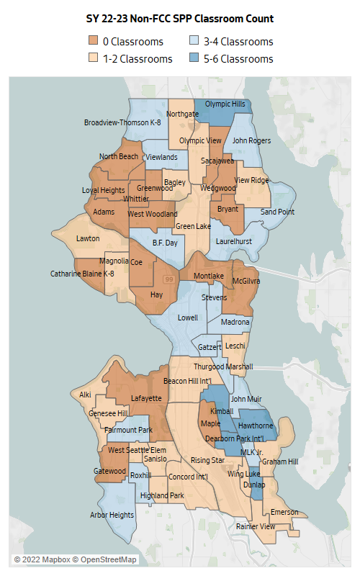
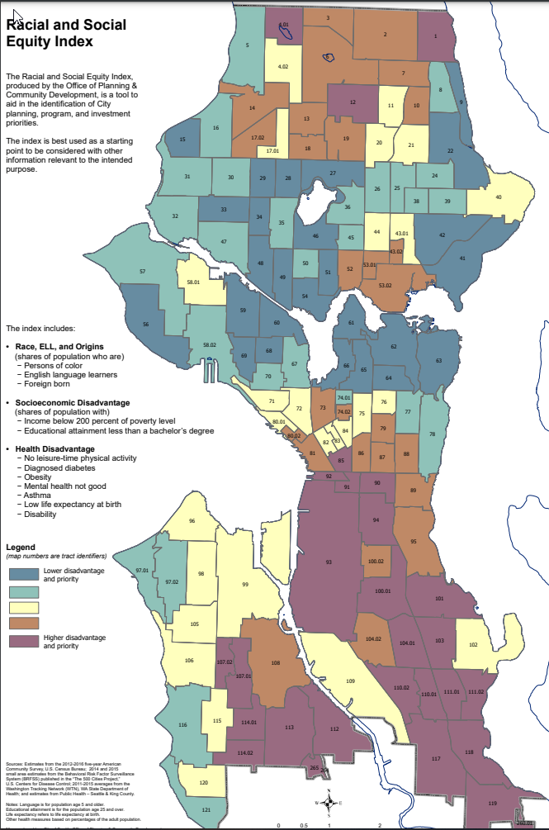
APPENDIX B – Technical Assistance
We encourage home-based providers to apply. Based on community feedback and past applications, DEEL will help smaller organizations with limited administrative capacity. If an application is submitted on time but needs more work (as determined by the evaluation panel), DEEL will match the agency with an architect through the Pre-Development program (see below for details) and/or DEEL program staff for specific technical assistance within 14 business days.

The agency will resubmit their application for review by DEEL program staff. An award decision will be made within 10 business days of resubmittal. DEEL will review any resubmitted applications until June 17, 2022. Thereafter, DEEL will encourage providers to apply in the next funding cycle.
SPP Pre-Development Services Program
Pre-Development Services are available to aid in expanding or improving your preschool facilities.

How can this support my work?
If you are considering an expansion or development project, this program will match you with a local architecture firm with experience in child care facility design. The firm assigned to you will provide DEEL-approved services related to planning for SPP facilities development projects. Projects that have been approved in the past include:
- Assessing the feasibility of facility expansion ideas
- Developing design options that fit your needs
- Developing initial drawings and cost estimates to get your project ready for construction
- Providing expert advice and partnership in the planning stages of SPP-related construction work you are considering

Who is eligible to apply?
Family child care, center, and school-based providers who contract with DEEL as providers of SPP or SPP Pathway.

How do I apply and receive services?
To apply for Pre-Development Services, contact Jenny Choi Jenny.Choi@seattle.gov to discuss your pre-development needs. You will then be asked to fill out a short online application at: https://www.surveymonkey.com/r/PreDevServices

Within two weeks, DEEL will decide on your application. If approved, DEEL will work with you and the architectural firm to develop a scope of work. DEEL will then execute a contract with the firm to do the work. You will receive a copy of any plans or assessments completed by the firm.

Who is providing the services?
Three highly qualified firms, listed below, have been pre-screened by DEEL and will provide services for this program. All firms have experience in childcare facility design and working with non-profit organizations.
- Anjali Grant Design - http://www.anjaligrant.com/
- CAST Architecture - https://www.castarchitecture.com/
- SABArchitects - http://sabarch.com/
Grant Writers are available to assist FCCs with understanding and completing the RFI application.
How can this support my work?
If you already met with an architect and have a feasible project looking for funding, DEEL can match you with an experienced grant writer to assist with the application requirements. This includes:
- Developing a workplan and calendar to complete the RFI application
- Ensuring applications are submitted by the deadline
- One-on-one conferences, phone calls, and emails as needed with the providers on the submission process
Who is eligible to apply?
Family child care providers who contract with DEEL as providers of SPP or SPP Pathway.

How do I apply and receive services?
To apply, contact Jenny Choi Jenny.Choi@seattle.gov who will match you with a grant writer.
May 11, 2022 is the last day to sign up to receive these services for the 2022-23 RFI cycle.

Who is providing the services?
Two highly experienced grant writers familiar with child care and facilities applications.
- Dr. Johnnie McKinley – Johnnie McKinley Associates LLC
- Kimberly Sopher-Dunn – New Birth CCI

Schneider, M. (2002). Do School Facilities Affect Academic Outcomes? National Clearinghouse for Educational Facilities: Washington, D.C.
High priority geographic locations include a) location in a census tract that is identified as medium or high priority according to the City of Seattle Race & Social Equity Index, or b) location in an SPS elementary school attendance Zone that has fewer than 5 school or center-based SPP classrooms.
http://www.seattle.gov/Documents/Departments/OPCD/Demographics/AboutSeattle/Race%20and%20Social%20Equity%20Index%20Map%202018.pdf

